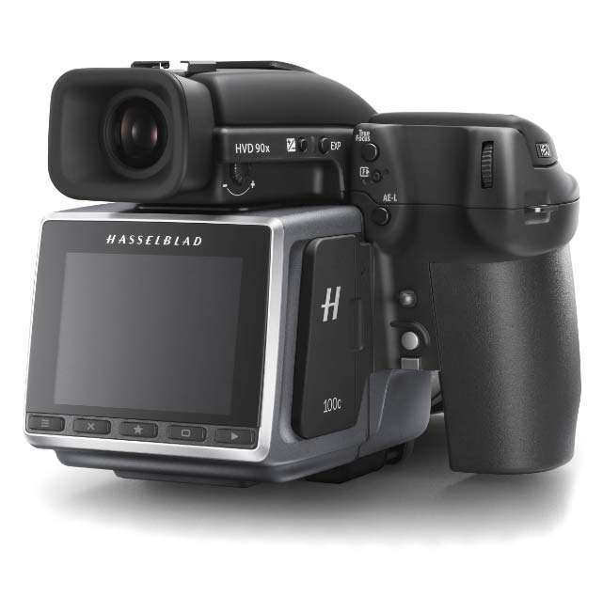

**( Medium Format Camera )**

What is the main difference between this type of cameras and other camera kinds?

1. Cencor Size
2. LCD Size
3. Weight
4. Mirrors